T

TIBCO BusinessEvents: BPMN Process Design Constraint

Product Suite | TIBCO BusinessEvents
Product | BPMN Processes
Product Version | 1.0
Initial Author | Manish Jha

Copyright Notice
- COPYRIGHT© 2011 TIBCO Software Inc. This document is unpublished and the foregoing notice is affixed to protect TIBCO Software Inc. in the event of inadvertent publication. All rights reserved. No part of this document may be reproduced in any form, including photocopying or transmission electronically to any computer, without prior written consent of TIBCO Software Inc. The information contained in this document is confidential and proprietary to TIBCO Software Inc. and may not be used or disclosed except as expressly authorized in writing by TIBCO Software Inc. Copyright protection includes material generated from our software programs displayed on the screen, such as icons, screen displays, and the like.
Trademarks
- Technologies described herein are either covered by existing patents or patent applications are in progress. All brand and product names are trademarks or registered trademarks of their respective holders and are hereby acknowledged.
Confidentiality
- The information in this document is subject to change without notice. This document contains information that is confidential and proprietary to TIBCO Software Inc. and may not be copied, published, or disclosed to others, or used for any purposes other than review, without written authorization of an officer of TIBCO Software Inc. Submission of this document does not represent a commitment to implement any portion of this specification in the products of the submitters.
Content Warranty
- The information in this document is subject to change without notice. THIS DOCUMENT IS PROVIDED "AS IS" AND TIBCO MAKES NO WARRANTY, EXPRESS, IMPLIED, OR STATUTORY, INCLUDING BUT NOT LIMITED TO ALL WARRANTIES OF MERCHANTABILITY OR FITNESS FOR A PARTICULAR PURPOSE. TIBCO Software Inc. shall not be liable for errors contained herein or for incidental or consequential damages in connection with the furnishing, performance or use of this material.
- For more information, please contact:
- TIBCO Software Inc.
3307 Hillview Avenue
Palo Alto, CA 94304
USA
Table of Contents
- Table of Contents
1 Table of Contents 3
2 Change Log 4
2.1 Related Documents 4
3 Introduction 5
3.1 Main Objective 5
3.2 Intended Usage 5
3.3 Scope 5
3.4 Naming 5
3.5 Audience 5
4 Acronyms and Vocabulary 6
5 Flow Elements Container 6
5.1 Pool 7
5.2 Lanes 7
6 Flow Elements 7
6.1 Events 7
6.2 Gateways 8
6.3 Sub Process 8
6.4 Sequence Flow 8

Change Log
- .
- Date | - Version | - Name | - Description
- 12/28/2010 | - 1.0 | - Manish Jha | - Initial doc

Related Documents
- Document Title | - Revision Number | - Author
- BPMN 2.0 Specification
- BE 4.1 BPMN Project Plan
- BE BPMN Requirements document |  | - Gabe Grigorescu

Introduction

Main Objective
- The objective of this document is to outline the BPMN elements design constraints of the BE BPMN Process Add-on functionality.

Intended Usage
- BE BPMN Decision Graphs will be used by different types of users. These users include: Business Owners, Business Analysts, Developers, IT Engineers.

Scope
- The scope of this document is to provide most of the execution documentation needed to describe how the codegen is created and how processes are executed.

Naming
- We have not decided yet how to refer to this new type of a process. Candidates include:
- Decision Graph
- (BPMN) Decision Process
- BE (BPMN) Process

Audience
- The document is intended for Developers, Architects, QA, Product Marketing, and Managers.

Acronyms and Vocabulary

The table below describes some of the Acronyms used in this documentation
- BE – TIBCO BusinessEvents.
- Studio Project – A TIBCO Project build using TIBCO BusinessEvents Studio.
- BPM – Business Process Model
- BPMN – Business Process Model Notation

Flow Elements Container

Pool
- One, and only one, Pool in a diagram MAY be presented without a boundary. If there is more than one Pool in the diagram, then the remaining Pools MUST have a boundary.

Lanes

Flow Elements

Events
- No Incoming sequence flow to start event
- No outgoing sequence flow to end event
- If there is a Start Event, then there MUST be at least one End Event.
- If the Start Event is used, then there MUST NOT be other flow elements that do not have incoming Sequence Flow—all other Flow Objects MUST be a target of at least one Sequence Flow.
  - Exceptions to this are Activities that are defined as being
Compensation Activities (have the Compensation Marker).
Compensation Activities MUST NOT have any incoming Sequence
Flow, even if there is a Start Event in the Process level.

  - An exception to this is the Intermediate Event, which MAY be without
an incoming Sequence Flow (when attached to an Activity boundary).

- If an End Event is used, then there MUST NOT be other flow elements that do not have any outgoing Sequence Flow—all other Flow Objects MUST be a source of at least one Sequence Flow.
Exceptions to this are Activities that are defined as being Compensation Activities (have the
Compensation marker). Compensation Activities MUST NOT have any outgoing
Sequence Flow, even if there is an End Event in the Process level.

- An Intermediate Event that is attached to the boundary of an Activity can only be used to “catch” the Event Trigger.

- The Boundary Event MUST NOT be a target for Sequence Flow; it cannot have an incoming Flow.
- The Boundary Event MUST be a source for Sequence Flow.
- Multiple Sequence Flow MAY originate from an Boundary Event. For each Sequence Flow that has the Intermediate Event as a source, a new parallel path SHALL be generated.
- An exception to this: an Intermediate Event with a Compensation Trigger MUST
NOT have an outgoing Sequence Flow (it MAY have an outgoing Association).

Gateways
- A Gateway MUST have either multiple incoming Sequence Flow or multiple outgoing sequence Flow (i.e., it must merge or split the flow).
    - A Gateway with a gatewayDirection of unspecified MAY have both multiple
incoming and outgoing Sequence Flow.
    - A Gateway with a gatewayDirection of mixed MUST have both multiple incoming and
outgoing Sequence Flow.
    - A Gateway with a gatewayDirection of converging MUST have multiple
incoming Sequence Flow, but MUST NOT have multiple outgoing Sequence Flow.
    - A Gateway with a gatewayDirection of diverging MUST have
multiple outgoing Sequence Flow, but MUST NOT have multiple incoming Sequence Flow.

Sub Process

- An Event Sub-Process is not part of the normal flow of its parent Process—there are no incoming or outgoing Sequence Flow.
- An Event Sub-Process MUST have one and only one Start Event.
- The Start Event of an Event Sub-Process MUST have a defined trigger. The Start Event trigger (EventDefinition) MUST be from the types: Message, Error, Escalation, Compensation, Conditional, Signal, and Multiple
- All Start Events for a standard Sub-Process MUST be of type None.
- For standard Sub-process start and end events are optional.

Sequence Flow

- Sequence flow connection rules as per table below
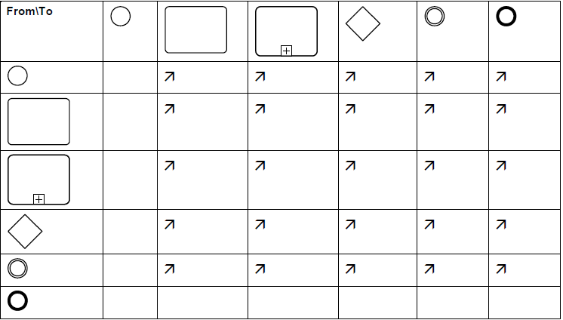
- Objects within the Sub-Process cannot be connected to objects outside of the Sub-Process
- Sequence Flow can not cross a Pool boundary.

Artifacts

Text Annotation

- An Artifact MUST NOT be a target for Sequence Flow.
- An Artifact MUST NOT be a source for Sequence Flow.

Association

- One end of association must be non flow object(like text annotation)
- One end of association must be flow object.

